**CHAPTER I**

**INTRODUCTION**

Early detection and segmentation of Brain tumors is very important in clinical practice. Many researchers have proposed different techniques for the classification of brain tumors based on different sources of information. In this paper we propose a process for Brain tumor segmentation, focusing on the analysis of Magnetic Resonance (MR) images and computed tomography (CT) scan. The MRI scan is more comfortable than CT scan for diagnosis. It is not affect the human body because it does not use any radiation. On other hand, Brain tumor is one of the leading causes of death among people. Brain Tumor segmentation deals with the implementation of simple for detection of range and shape of tumor in brain MR images. One view of image segmentation is clustering problem that concerns how to determine which pixels in an image belong most appropriately. K-means algorithm can detect a brain tumor faster than any other algorithm.

**1.1 OVERVIEW**

This paper deals with an automatic approach for brain tumor segmentation and detection. Basically, the tumor is an unconstrained growth of tissues in the brain. This tumor, when turns into cancer become potentially fatal. So in medical imaging, it is necessary to detect the perfect location of a tumor and its type. For detection and identification of brain tumor, MRI is the better option. A brain tumor is an intracranial mass produced by an unconstrained growth of cells either normally found in the brain such as neurons, cells, blood vessels, pituitary and pineal gland, lymphatic tissue, skull or spread from cancers predominantly located in other organs. Brain tumors are classified based on the location of the tumor, the type of tissue involved whether it is benign or malignant [1] [3].

1) Benign brain tumor: This type generally does not consist cancer cells and can be removed. It usually has an obvious border or edge. They don't spread to other parts of the body. However, benign tumors can cause serious health issues.

2) Malignant brain tumor: This consists cancerous cells and hence also called as brain cancer. They grow rapidly and can affect nearby healthy brain tissues. This can be a threat to life.

Depending on the type of cell causing tumor, doctor groups brain tumor by grades. Over time, a low-grade tumor may become a high-grade tumor. For diagnosis of brain tumor, MRI provides rich information about the basic structure, enabling quantitative pathological or clinical studies. The fundamental aspect that makes segmentation of medical images difficult is the complexity and instability of the anatomy that is being imaged. It may become impossible to locate certain structures without detailed anatomical mastery. This makes general segmentation complicated, as the information must either be built into the system or provided by the operator. For this, Matlab R2014b version 8.4 is used over the 64-bit operating system on intel (R) core i5 processor with inbuilt 4 GB RAM and 500GB hard disk

**1.2** **LITERATURE SURVEY**

A. Image Enhancement

Image enhancement is one of the major research fields in image processing. In any applications such as medical application, military application, media etc., the image enhancement plays an important role. Recently, neural networks turn to be a very effective tool to support the image enhancement. Neural network is applied in image enhancement because it provides many advantages over the other techniques [1]. Also, neural network can be suitable for removal of all kinds of noises based on its training data. This paper provides survey about some of the techniques applied for image enhancement. In addition to saving time, the proposed system can improvise in such a way as to provide protection and security to the baggage of the passengers. The system works in such a way that the tags provide security to the bags where the bags can be checked for their respective passenger.

B. Morphology

Morphological processing is constructed with operations onsets of pixels. Binary morphology uses only set membership and is indifferent to the value, such as gray level or color, of a pixel. Morphological image processing relies on the ordering of pixels in an image and many times is applied to binary and gray scale images. Through processes such as erosion, dilation, opening and closing, binary images can be modified to the user's specifications [2,3]. Binary images are images whose pixels have only two possible intensity values. They are normally displayed as black and white. Numerically, the two values are often 0 for black, and either 1 or 255 for white. Binary images are often produced by thresholding a gray scale or color image, in order to separate an object in the image from the background. The color of the object (usually white) is referred to as the foreground color. The rest (usually black) is referred to as the background color. However, depending on the image which is to be threshold, this polarity might be inverted, and in which case the object is displayed with 0 and the background is with a non-zero value.

C. Morphological Segmentation

This section details the segmentation of mammograms for identifying the tumor in brain. The proposed approach utilizes mathematical morphology operations for the segmentation. The morphological operations are applied on the gray scale images to segment the abnormal regions [4,5]. Erosion and dilation are the two elementary operations in Mathematical Morphology. An aggregation of these two represents the rest of the operations of opening and closing. And all of these together forms the four fundamental binary morphological operations: dilation, erosion, opening, and closing.

**1.3 OBJECTIVE**

The main objective of this project is,

* Processing an MRI image
* Segmentation of the MRI image of brain
* Identifying tumor in the image
* Calculating the tumor size if tumor is present

**CHAPTER II**

**SYSTEM ANALYSIS**

**2.1 EXISTING SYSTEM**

The system study involves the study of existing system about kmeans clustering in brain MRI segmentation.

**2.1.1 Drawbacks of existing system**

* Does not provide the size of the tumor
* Does not provide the binary image of the tumor
* Provides visual recognition alone

**2.2 PROBLEM DEFINITION**

The conventional method of reading the MRI image can be completely overthrown by doctors as the image is processed by the system itself and the result is provided such that the exact tumor size is also given.

**2.3 PROPOSED SYSTEM**

A. MRI image acquisition

1) Data collection: The input MRI images have been collected from different online open source database available for research work in DICOM, .MHA and .JPEG format.

2) Image format Conversion: The majority of the images collected was in .MHA format; hence they have been exported into a more usable format i.e. Medical Imaging Interaction Toolkit. For .DICOM image we used DICOM viewer software tool.

3) Size normalization:

The images have been acquired from different sources; hence, they are of variable size. All images have been size normalized to be of size 255*255 pixels.

B. Image pre-processing

1. By changing the image mode to gray-scale, remove the color components for FCM and K-MEANS

2. Enhance the quality of the image by a median filter.

3. Plot the histogram to study and analyze the intensity distribution of the pixels.

4. Intensity adjustment if needed.

5. Histogram equalisation

6. This section formats the input image as per the need of further stages

C. Segmentation

In this paper, K-means clustering is used mainly to cluster the input MRI image.In clustering process, partitioning or grouping of given unlabelled pattern sector into a number of clusters such as the similar patterns are assigned to a group. These groups are the known as clusters.

K-Means algorithm is an unsupervised clustering algorithm. [7] It classifies the input data points into multiple classes depending upon their intrinsic distance from each other. “K” is a number of clusters and it is always less than data points “n”. The algorithm assumes that the data features form a vector space and tries to find natural clustering in them. This algorithm selects the number of clusters k, then randomly generates clusters and determines the cluster centres. Then next step is to assign each data point to the nearest cluster centre and then recomputed the new cluster centres. These two steps are iterated until the minimum variance criterion achieved that means until the centre converges.

K-means Algorithm steps:

1. Give the number of cluster value as k. (k = 5)

2. Randomly choose the k cluster centres.

3. Calculate the centre of the cluster.

4. Calculate the distance between each pixel to each cluster centre.

5. If distance is near to the centre then move to that cluster.

6. Otherwise move to the next cluster.

7. Re-estimate the centre.

8. Repeat the process until the centre stops varying.

D. Post-processing

Clusters obtained from segmentation are reshaped to image file by Matlab function reshape ( ).

E. Feature extraction

In feature extraction, the tumor/ abnormal group of tissues are extracted from segmentation output image which is given to the thresholding process as input. The binary mask is applied over the entire image. It makes the white become brighter and dark pixel become darker. Each transform coefficient denoted by ‟T” is compared with a threshold in threshold coding. If ‟T” is less than the threshold then it is considered as zero otherwise ‟T” will be considered as one. Thresholding is an adaptive technique in which only those coefficients having value above a threshold are retained within each block.

F. Detection stage

In this stage, detection out of segmented image is made using the binarization method in the approximate reasoning step the area of the tumor is calculated. That means the image having two values either white or black (1 or 0). Here maximum image size is 256x256 jpeg image. We can represent a binary image as a summation of total number of black and white pixels .

Image, I= $\sum_{w=0}^{255}{\sum_{H=0}^{255}{f\left(0\right)+f(1)}}$-- (5)

Pixels = Height (H) X Width (W) = 256 X 256

f (l) = black pixel (digit 1)

f (0) = white pixel (digit 0)

No_of_white_pixel, P= $\sum_{w=0}^{255}{\sum_{H=0}^{255}{f\left(0\right)+f(1)}}$-- (6)

Where, P = Total number of white pixels (height * width)

1 Pixel = 0.264 mm

The formula for area calculation is

Size_of_tumor, S= √P ∗0.264 mm2 --- (7)

P= Number of white pixels; H=height, W=width;

Detection stage Algorithm steps:

The algorithmic steps involved for brain tumor detection is as follows-

1. Use .JPEG MRI images from a database or real-time system as input.

2. Checks whether the input image format is as specified and move to step 3, otherwise display an error message.

3. Verify that image is gray image. If not then convert to gray-scale using rgbtogray ( ) function in Matlab.

4. Find the edge of the grayscale image using binarization and thresholding method.

5. Calculate the total number of white pixels (digit 0) in the image.

6. With the help of the formula, calculate the size of the tumor.

7. Compare the area obtained with 6mm2. If the area is greater than 6mm2 then Brain MRI image has severe abnormality.

8. Display the tumor size and stage.

9. Stop the process.

**2.3.1 Advantages of proposed system**

* Provides efficient method to recognize tumor in a brain MRI.
* This method can be used as a model for further implementation and use for future reference.
* One of the most easiest ways to understand and implement K means clustering in real life.
* Provides forward compatibility .

**CHAPTER III**

**SOFTWARE REQUIREMENT SPECIFICATION**

**3.1 INTRODUCTION**

The following describes the requirement specification for detecting and segmentation of tumor of brain MRI.

**3.2 PLATFORM DESCRIPTION**

**3.2.1 Matlab**

MATLAB (matrix laboratory) is a multi-paradigm numerical computing environment. A proprietary programming language developed by MathWorks, MATLAB allows matrix manipulations, plotting of functions and data, implementation of algorithms, creation of user interfaces, and interfacing with programs written in other languages, including C, C++, C#, Java, Fortran and Python.

Although MATLAB is intended primarily for numerical computing, an optional toolbox uses the MuPAD symbolic engine, allowing access to symbolic computing abilities. An additional package, Simulink, adds graphical multi-domain simulation and model-based design for dynamic and embedded systems.

As of 2017, MATLAB has over 2 million users across industry and academia. MATLAB users come from various backgrounds of engineering, science, and economics.

**3.2.2 Other Requirements**

* 500 gb RAM
* 64-Bit operating System
* Minimum of i3 processor

**CHAPTER IV**

**SYSTEM DESIGN**

**4.1 FLOW DIAGRAM**

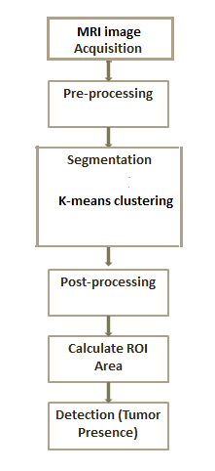

Fig 4.1 Flow diagram

The following block diagram describes the flow of processing image acquired from the user. The image acquisition and preprocessing involves getting an image from the user and converting it into gray scale based on the size of the image. After the gray image is obtained it is spilt into clusters using k means clustering giving about four segmented images from which the user can check for tumor in the specific images. Finally the area of tumor is calculated and verified for the presence of tumor in that segment.

* 1. **MODULE DESCRIPTION**

The system can be divided into three modules based on their process. They are

* Acquiring image
* Clustering the image
* Calculating tumor area

**4.2.1 Acquiring MRI image**

The module involves acquiring an MRI image as an input from the user. The image can be of .jpeg format or any other format like DICOM or MHA. If such an image is obtained, it should be opened or converted using specific software like Slicer 4.6.2.

**4.2.2 Clustering the image**

The input image is now processed and converted into clusters using K-means algorithm. Here about four clusters are made using the input image. The clusters are formed using colors of the gray scale image as the centroids. In order to convert it into several segments, the image is segmented using the clustering algorithm. Now, about 4 segments are obtained.

**4.2.3 Calculating tumor area**

The user can identify the tumor from segmented images and so a segment is chosen as an input. the segment is converted into number of white and black pixels. The number of white pixels provide the area of the tumor with which it can be checked and its presence is confirmed.

**CHAPTER V**

**SYSTEM IMPLEMENTATION**

**5.1 IMAGE ACQUISITION**

* This module describes the input image from which the gray scale image is obtained for further processing.

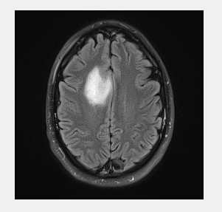

Fig 5.1 Input MRI image

The input MRI image of the brain is converted into 255*255 sized image. Later the image is converted into gray scale image. The rgb image is converted using matlab software into gray scale and the index image with segments is obtained.

**5.2 CLUSTERING THE IMAGE**

* This phase consists of clustering and processing the input image to obtain several segmented images.

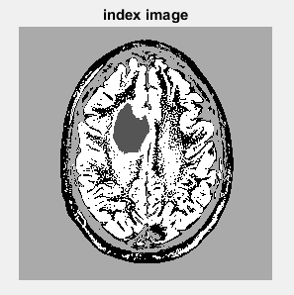

Fig 5.2 Index image

Based on the difference in colors seen in the gray scale image, the centroids are fixed such that, the image is clustered into four clusters with difference in colors. By this process, we acquire about four segments of the image where, four clusters were obtained.

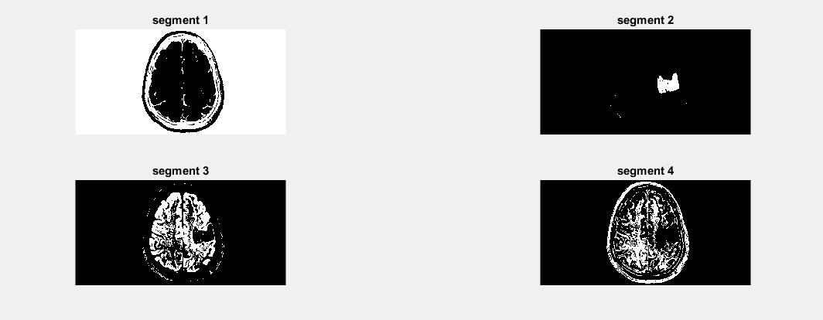

Fig 5.3 Segmented Image

**5.3 CALCULATING AREA OF TUMOR**

* This module helps in calculating the exact size of the tumor seen in the segments.

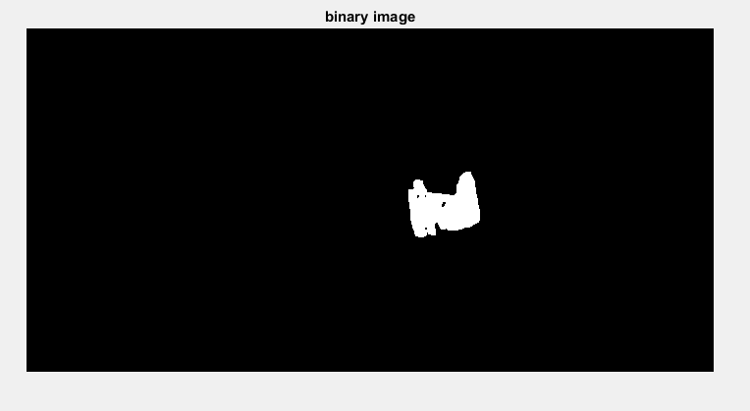

Fig 5.4 Binary image

Here, the segmented image is binarised and the total number of white pixels in the binary image is calculated to find the area of the tumor. The total number of white pixels with respect to the size of the image can be used to calculate the area of the tumor. Any tumor which is above 6mm2 is considered to be an abnormality and treated as a tumor.

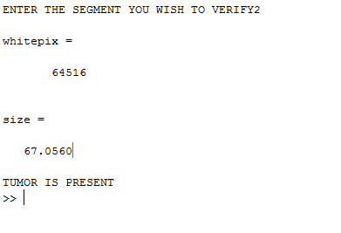

Fig 5.5 Command Prompt

The command prompt provides information as to how many white pixels the binary image has and with that information, the area of the tumor is calculated and displayed in the command prompt. Along with the size of the tumor, for easy understanding of the user, the result as to tumor is present or absent is verified.

**CHAPTER VI**

**SYSTEM TESTING**

**6.1 TESTING**

System testing is the process of validating and verifying that a system

* meets requirements that guided its design and development
* works as expected
* Can be implemented with the same characteristics.

So, testing has been carried out to check whether the proposed system has met the requirements and has derived the expected result.

* + 1. **Test cases of modules**

|  |  |  |  |
| --- | --- | --- | --- |
| **S.No.** | **Module** | **Input** | **Expected Output** |
| 1 | Acquiring image | MRI image of brain | Gray scale image with proper size |
| 2 | Clustering image | Gray scale image | Segments of images based on clustering |
| 3 | Calculation of size | Segmented image | Binary image and the size of the tumor |

Table 6.1 Test cases of Modules

**6.2 TESTING METHODOLOGIES AND POLICIES**.

System testing is a process of checking whether the developed application is working according to the original objectives and requirements. The system should be tested experimentally with test data so as to ensure that the system works according to the required specification. When the system is found working, test it with actual data and check performance.

All tests should be traceable to passenger requirements. The focus of testing will shift progressively from programs. Exhaustive testing is not possible. To be more effective, testing should be one, which has probability of finding errors.

The following are the attributes of good test

* A good test has a high probability of finding an error.
* A good test is not redundant.
* A good test should be “Best of Breed”.
* A good test should neither too simple nor too complex.

**6.2.1 LEVELS OF TESTING**

The details of the software functionality tests are given below. The testing procedure that has been used is as follows:

* + Unit Testing
  + Verification Testing
  + Performance Testing

**6.3 UNIT TESTING**

The first level of testing is called as unit testing. Here the different modules are tested and the specifications produced during design for the modules. Unit testing is essential for verification of the goal and to the test the internal logic of the modules. Unit test was conducted to the different modules of the project. Errors were noted down and corrected down immediately and the program clarity was increased the testing was carried out during the programming stage itself. In this step each module is found to be working satisfactory as regard to the expected output from the module. The modules like Passenger Module, Authority Module etc., were tested.

**6.4 VALIDATION TESTING**

The next level of testing is validation testing. Here the entire software is tested the reference document for this process is the requirement and the goal is to see if the software meets its requirements. The requirement document reflects and determines whether the software function as the user expected. At the culmination of the integration testing, software is completely assembled as a package, interfacing and corrected and final serious of software test and validation test begins. The proposed system under construction has been tested by using validation testing and found to be working satisfactory. After finishing the integration testing, the modules were tested for validation

**6.5 PERFORMANCE TESTING**

To ensure consistent results, the performance testing environment is isolated from other environments, such as user acceptance testing (UAT) or development. As a best practice it is always advisable to have a separate performance testing environment resembling the production environment as much as possible. Performance testing includes the following activities:

* 1. Identify the Test Environment
  2. Plan and Design Tests
  3. Configure the Test Environment
  4. Implement the Test Design
  5. Execute the Test
  6. Analyze Results, Tune, and Retest

**CHAPTER VII**

**CONCLUSION AND FUTURE ENHANCEMENT**

**7.1 CONCLUSION**

Thus in our proposed method, we combine segmentation and K-means clustering. It can be deduced from the results that unsupervised segmentation methods are better than the supervised segmentation methods. Because for using supervised segmentation method a lot of preprocessing is needed. More importantly, the supervised segmentation method requires considerable amount of training and testing data which comparatively complicates the process. This study can be applied to the minimal amount of data with reliable results. However, it may be noted that, the use of K-Means clustering method is fairly simple when compared with frequently used fuzzy clustering methods.



Some special features of this project are

* Extremely simple algorithm.
* Accurate and more reliable than conventional methods
* Region of interest can be acquired accurately.
* This can be applied to minimal amount of data with reliable results.
* Can be used to cross-verify the doctors decision.
* Reduces the computational complexity.
* Can be collaborated with other algorithms easily for increasing the efficiency.
  1. **FUTURE ENHANCEMENTS**
     + This paper serves as a base for several applications
     + It can be combined with several other algorithms easily and can be checked for further future reference.
     + This algorithm can be used for several other applications in image segmentation rather than brain alone.
     + It can provide higher resolution and accuracy when combined with morphological and several other segmentation techniques.
     + To overcome the drawbacks, several techniques are combined to provide more accurate results.

**APPENDIX 1**

**SAMPLE CODING**

**MATLAB PROGRAMMING :**

clc;

clear all;

close all;

warning off;

a=rgb2gray(imread('tumor1.jpg'));

figure,imshow(a);

%%

bw = reshape(a,[],1);

bw = double(bw);

[IDX, nn] = kmeans(bw,4);

imIDX = reshape(IDX,size(a));

%%

figure,

imshow(imIDX,[]),title('index image');

%%

figure,

subplot(3,2,1),imshow(imIDX==1,[]),title('segment 1');

subplot(3,2,2),imshow(imIDX==2,[]),title('segment 2');

subplot(3,2,3),imshow(imIDX==3,[]),title('segment 3');

subplot(3,2,4),imshow(imIDX==4,[]),title('segment 4');

%%

prompt='ENTER THE SEGMENT YOU WISH TO VERIFY';

str=input(prompt);

bw = (imIDX==str);

se = ones(5);

bw=imopen(bw,se);

bw=bwareaopen(bw,400);

figure,imshow(bw),title('binary image');

%%

xmax=255;

ymax=255;

whitepix=0;

for i=1:(xmax)-1

for j=1:(ymax)-1

if bw(j,i)==0

whitepix=whitepix+1;

end

end

end

whitepix

size=sqrt(whitepix)*0.264;

size

if(size>6)

disp("TUMOR IS PRESENT");

else

disp("TUMOR IS ABSENT");

end

%%

**REFERENCES**

1. J.Vijay and J. Subhashini “An Efficient Brain Tumor Detection Methodology Using K-Means ClusteringAlgorithm ” International conference on Communication and Signal Processing, April 3-5, 2013, India
2. Jinal A. Shah 1, S. R. Suralkar “Brain Tumor Detection from MRI Images using Fuzzy C-Means Segmentation” International Journal of Advanced Research in Computer and Communication Engineering Vol. 5, Issue 6, June 2016
3. Sonu Suhag and L. M. Saini,“ Automatic Detection Of Brain Tumor By Image Processing In Matlab”, SARC-IRF international conference, may-2015.
4. Arash Azim Zadeh Irani and Bahari Belaton "A K-means Based Generic

Segmentation System" 2009 Sixth International Conference on Computer

Graphics, Imaging and Visualization.

1. Ming-Ni Wu, Chia-Chen Lin and Chin-Chen Chang "Brain Tumor Detection Using Color-Based K-Means Clustering Segmentation" International Conference on Computer Graphics,2009.